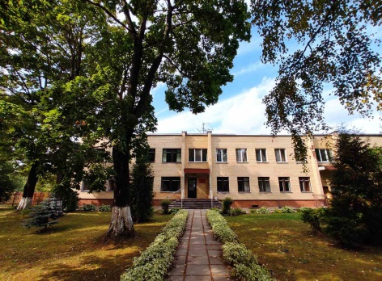
The humanitarian project
of the state educational institution
"Fanipol Children's School of Arts"
is looking for sponsors

The purpose of the project: to find funds for the implementation of projects of the children's folklore ensemble "Dudorochki", contributing to the preservation and affirmation of the primordial folk traditions.
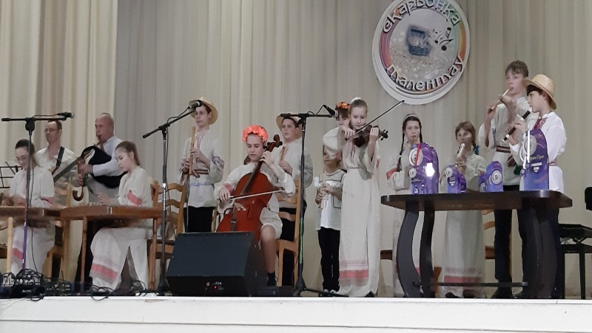
1. Name of the project: "Return to the origins"
2. Project implementation period January 2025 - December 2027
3. Applicant organization offering the project: GUO "Fanipol Children's Art School" Dzerzhinsky district, Minsk region
4. Objectives of the project: search for funds for the implementation of projects that contribute to the preservation and affirmation of the ancestral folk traditions, the formation of a respectful attitude to the small homeland, through the introduction of children to the Belarusian folk culture.
5. Tasks planned for implementation within the framework of the project:
1. Purchase of Belarusian folk instruments (Belarusian duda, lyre, zhaleyki, pipes, various percussion noise instruments)
2. Tailoring of national costumes.
3. The arrangement of a stage platform for various concerts, rituals, folk – scenic actions.
4. Organization of folklore expeditions from students and teachers on Dzerzhinsky district.
5. International folklore cooperation.
6. Target group: students and teachers of Fanipol children's schools, residents of Fanipolsky district.
7. Brief description of the project activities:
1. Performance of the band at various concerts of the city, district, region in order to attract people's attention to the Belarusian national culture.
2. Enriching the concert repertoire, searching for new means of expression
3. Conducting rituals: "Kolyady", "Maslenitsa", "Gukanneviasny"
4. Participation in folklore projects of Belarus and CIS countries.
8. Total funding (in US dollars)
Source of financing | Amount of financing  (in US dollars)
Donor funds | 7000
Co-financing | 1000
9. Project location (region/district, city):
Minsk region, Dzerzhinsky district, Fanipol.
10. Contact person:
Sochivko Ekaterina Sergeevna, Director of the State Educational Institution "Fanipol Children's Art School" +375296240806, fanmuz@dzerzhinsk.gov.by

